**NATIONAL COLLEGE OF IRELAND**

**Work Placement Final Report**

Name:

Student ID:

Course:

Date:

**Introduction**

This report underlines the objectives of my work placement in ___________ and the experience I have gained throughout the placement. The report follows the standard guidelines provided by National College of Ireland

This report is a summary of __________months I worked with ________during the period _________

At the end of my report I have outlined my opinion of the work placement and any recommendations for future work placements

My monthly reports are attached at the end of this document

**DECLARATION BY THE STUDENT**

**Module: ______________________________________**

**Course: ______________________________________**

**Name: _______________________________________**

**Address______________________________________**

**Home Telephone No: ___________________________**

I wish to submit my Industrial Work Placement Final Report, I submit this documentation in accordance with the requirements of the B.Sc. in Computing / B.Sc. in Business Information Systems.

I certify that all information submitted with this claim is an accurate description of my learning experience on the Industrial Placement module

Signed: ____________________________ Date: ___________________

**TABLE OF CONTENTS**

1. **SETTING THE CONTEXT**

Name and nature of the host company

Length of placement

Nature of the work placement

Name of workplace supervisor(s)

Name of National College of Ireland supervisor

1. **ORGANISATION PROFILE**

Role, Function and mission statement of company

Brief history of company

1. **DESCRIPTION OF DUTES UNDERTAKEN,**

Summary of projects completed

Technical/business experience acquired.

1. **ACCOUNT OF ACTUAL WORK EXPERIENCE**

Initial expectations and anticipated outcome

Actual Outcomes

Lessons Learnt

Responsibility

Training Courses attended

1. **PERSONAL PROFILE AND RELEVANCE TO THE COMPANY**

What dimension did the student bring to the work placement?

What benefits did the student derive from the work placement?

Did the placement assist the student in terms of future career planning?

1. **ATTAINMENT OF THE LEARNING OBJECTIVES OF INDUSTRIAL PLACEMENT**

Statement of the Learning Objectives

Assessment of the degree to which the objectives were attained

Additional learning outcomes achieved

1. **REFLECTION ON CURRICULAR RELATED ISSUES**

Reflections on the synergy between the work experience and the B.Sc, in Software Systems / Business Information Systems

Did the placement contribute to the choice of the final year project?

1. **CONCLUSIONS**

Individual thoughts on the overall experience

Recommendations about future work placements

**APPENDICES**

Curriculum Vitae of the student

Monthly Learning Reports

Record of courses attended or skill certifications attained during the Industrial Placement Programme

Student Self-Assessment Evaluation

## 

1. **SETTING THE CONTEXT**

Name and nature of the host company

Length of placement

Nature of the work placement

Name of workplace supervisor(s)

Name of National College of Ireland supervisor

The academic internship I attained was with the Revenue Commissioners at their Information and Communications Technology & Logistics Division offices on South Great Georges Street. The role of the company is self-explanatory – they are responsible for collecting the taxation of the country. The internship started at the beginning of February and ran through the middle of August, all in all a period of more than 6 months. I was placed on the Programme Management Office, or PMO for short, team. The PMO is focused on internal matters, for instance trying to improve current process’ for the benefit of the whole of Revenue. Alan Heade was the workplace supervisor assigned to me. He is the team leader of my unit in the PMO which was the Portfolio Management Unit. My college supervisor was Lisa Murphy, who visited during the month of May.

1. **ORGANISATION PROFILE**

Role, Function and mission statement of company

Brief history of company

As well as their main role of the collection of the countries tax, the Revenue commissioners are also responsible for roles pertaining to tax like debt management, auditing, tax assessment as well as roles maybe not as blatantly obvious like customs at airports and ports. Indeed, official Revenue documentation describe them as “*the Government agency responsible for taxation, customs, excise and related matters.”* It’s hard to put an exact date but the current amalgamation of the Revenue Commissioners has been going since Ireland procured its independence and is growing larger each year ever since. Currently there over six thousand members of staff are located throughout different offices in Ireland working in an interlinked manner. The role of technology in Revenue is obviously one which has grown exponentially in the last twenty years. Before everything relating to tax was processed manually starting from a consumer sending hand written form to this being looked at by and processed by an employee to them the sending a letter being sent back in response. This meant there were a lot of clerical employees in the company. Indeed a clerical officer is a whole position rank in the whole civil service such was there need. There was a huge transition in the company to move to a more automated IT driven system. This enabled a huge growth in the employment of IT staff especially in development.

On the IT side of Revenue there are over four hundred staff employed, both in numerous locations in Dublin and Limerick. It is an extremely busy time in IT in Revenue with the modernisation of taxation occurring as well as preparing for Brexit. Although many government IT components may be seen as backward by some, IT in Revenue is quite progressive which can be seen online through the recently launched revenue online service. This redevelopment was achieved in 2017 and one year the site has a total of twenty-two million separate hits receiving almost two million views each month which shows the scale of the development which happened din the office on South Great Georges Street. A major project is happening at the moment in the Revenue Commissioners office is the modernisation of the taxation system which will mean real time paying of tax, instead of the tax being taken off employers in a batch at the end of the day and an abolition of forms like P45 and P60 instead an online user account will hold all necessary information. This project is the biggest IT project undertaken by Revenue which a launch scheduled for January 2019. A project of this scale shows the investment, commitment and faith Revenue is putting in technology and its employees.

1. **DESCRIPTION OF DUTES UNDERTAKEN,**

Summary of projects completed

Technical/business experience acquired.

As soon as I began at Revenue I was placed on a project which would encompass my whole academic internship. The project was developing an internal web application for use in recruitment from scratch using AngularJS with the Spring stack, which would allow for the Corporate Services Division or CSD, of Revenue to have a system relating to internal jobs. CSD is per say the main HR unit of Revenue based in Dublin Castle. One of the main functions of CSD is recruitment. Their recruiting process would be all roughly based on email and Microsoft Office. An email displaying everything relating to the job coupled with a Word doc application would be circulated. Any applicants would have to return this document fully completed. CSD would tally all submitted documents by using an automation program called BluePrism to display this data in Excel sheets where the anymore information would be manually inserted like interview details.

With such a convoluted system it’s no surprise a more modern process was sought. Many things could go wrong with this way of doing things. They are relying on no human error and for anyone updating these excel to follow the correct layout. There’s also data issues – it was noted in an early meeting that a team member must go through each application word doc first to make sure the applicant correctly filled in the doc. If not, gaps would be created in the excel and render them null. Another whole realm of discussion would be around being data compliant especially in these GDPR times which came in in the midst of the internship timeframe.

The project system design adequately overcomes these issues and advertises internal open jobs while also allowing employees to apply and track their progress. A reporting section would also be included. In essence the intention was to develop a vibrant recruitment system for the whole of Revenue. It would be in the mould of something lie publicjobs.ie where a user could search jobs and apply but they’d also be able to gather everything relating to the job interview e.g. interview times, if the application is successful, all in the system.

The project was assigned to be developed by a fellow PMO intern and I, with some guidance from the unit’s software developer with the timeframe of completing the development by the end of the internship. Such was the size and scope of what I was working on, this project took up all my time in Revenue, I was not placed on anything else and as of the time of writing, I would estimate the project is at 90% competition from a development point of view.

A lot of technical and business experience was acquired purely from the project especially as I was present throughout the whole process. On the technical side I was working with technologies I’ve never used before along with ones I would have some familiarity with. The project was developed using AngularJS. Coming into the internship I never used Angular so a huge amount of experience was gained. I would estimate that every working day I encountered Angular in some way so it was quite an intensive internship where Angular is concerned. Along with Angular the main pillars of front end web design were polished upon namely HTML, CSS and JavaScript. In the backend Java was used and Apache being applied for server running. Spring framework was used for building the web application using the Spring IDE. Version control was at the forefront of the whole development with a Revenue version of GitLab used in depth. JSON was used for mock data purposes while waiting on the stores to be built. A small bit of SQL was acquired for some querying of data.

Business wise a huge amount of knowledge was gained first hand throughout the cycle of the project. Prior to any development a business requirement specification document of over thirty pages was handed out which contained all requirements down to the minutest of details. This document also enclosed MoSCoW analysis on the prioritisation of tasks. This was all signed off by the business sponsor prior to the development commencement. A functional specification document was then created by the team with more precise information on what will be developed. These were drawn to extensively for development purposes during the path of the project.

Agile methodology was used for the project development. Every morning there was a daily stand up where each team member would state what they did yesterday, what they’ll do today and any problems of which may occur. This was in the company of the whole team including supervisor. Alongside the stand-up there were many meetings, with the vast majority from a business point of view where discussions were held on the viability of developing certain features, what’s next and what’s best for the stakeholder keeping in mind the business requirement specification.

Throughout the whole process I was exposed to business standards without even knowing it. There was a strict time frame on every part of the development with consistent reporting back to the project lead who is purely from a business background. This instilled a project professionalism which will for sure help me in the future. Even the way in the manner of issues were dealt with is something I gained so much from, perhaps it could be called formal etiquette. This etiquette was also acquired from the unit I was placed in the PMO. This was predominately a business team and a team I shared an office with for six months. I seen first-hand the process of managing development and even working to realise the benefits of projects. No development just starts, a whole lot of underwriting occurs first, the development may even be least convoluted of the project process. The development team isn’t in charge of anything at all, the amount of meeting I personally attended which felt like a chore to me at the time, opened my eyes to the amount of documentation and reporting to higher ups in the company is necessary. Every decision has to be greenlit by someone more senior.

The project followed rigid scheduling something I’ve never experienced in relation to any projects I have ever been involved in. Everything which had to be developed was broken down into stiff, smaller parts. This scheduling then had to be followed which put a pressure on and dealing with this pressure and timeframe is something I gained.

In general, with the project being developed for a part of the company in another building, a major amount of liaising was required during the development cycle. This came in many forms including email, presentations and meetings in either building. There was an especially formal presentation around mid-way through the placement which involved presentation to quite senior figures in the departments of which the project relates to. This experience can only be of a benefit going forward.

1. **ACCOUNT OF ACTUAL WORK EXPERIENCE**

Initial expectations and anticipated outcome

Actual Outcomes

Lessons Learnt

Responsibility

Training Courses attended

Before I started to be completely honest I felt a tangible bit daunted the prospect of working in a place of the relevance Revenue has in everyday life, just ignorantly perhaps I subconsciously expected working in a big team in a formalized workplace of mainly robots who are able to perform to a scandalously high standard at all times every day. However, I expected that after a small settling in period of watching others and fetching coffees that I would get to a full time staff standard relatively quickly. With it being revenue there was a certain expectation I would be working with people’s data. As I haven’t held an office role before I naively expected an extremely busy place where socially I would have to work to fit in also. I also wasn’t sure what my role actually was in the company as the extremely broad ‘Junior Developer’ was the term given. This gave me no intention of anything in particular and in fact added to a sense of dread pre- to starting. Based off the interview I expected to be allocated to the data analytics team which is which I mentally planned for.

The first day of starting was one which changed my preconceived conceptions from the outset. Firstly, I walked into a mainly silent and quite dead office environment where there was no real conformed culture. Secondly, I wouldn’t be working on the data team whatsoever, I would be developing internal web applications. I was placed on a small team with a fellow intern which was while IT focused not technical IT focused at all. The team was also very small especially the developing team and it was not an overestimation to say the fellow intern and I, after joining accounted for 66% of the development team. In a way while I expected to learn off loads of people, learning off one made for a better experience as far as I’m concerned as we formed a close-knit group who could bounce ideas off each other in an open environment. It also strange that the team leader who we’d report to had no technical IT experience. I was closely aligned with the other intern for the whole internship which turned out to be extremely beneficial as probably only perception wise I originally found it awkward being an ‘intern’. For me it signifies being temporary and not a full employee but this if I am being honest was all in my head and no one treated me any differently especially not in the PMO team but having another intern was helpful to stop this perception take over.

The actual team dynamics in PMO were non-existent. Mainly everybody kept to themselves with no social demands whatsoever. There was also no coffee getting or anything of the kind.

I was disappointed not to be placed working with data because at the time it was something I wanted to work with and one of the reasons I chose this placement. In retrospect after the placement I have no interest and can’t see myself working within the data analytics/

The environment and workload really surprised in the early few weeks. It was such a casual place with no dress code and flexi time which turned out to be a great well utilised tool. In my team there was no overhead watching my every move – I was given space to be breath by my team leader which I really prefer. This made the first few weeks completely different especially juxtaposed with my initial expectations. This was really highlighted in the first few weeks. As I had no experience using Angular, my tasks only consisted of doing online tutorials with the assigned project I would be working on put to the side until I felt had adequate knowledge to start. This initially amazed me – I had come straight from working in retail, where management are always micromanaging, to this. Again, it was not what I thought it would be like. However, in a way at the start I expected a bit more professional as I was just using free online tutorial to get me up to scratch. Now I know it’s all about self-learning in every field, this is the adult world – no one is going to hold my hand I have to be proactive and gain the skills myself.

Inside about the first three weeks we pushed ahead with starting the project. Unlike interns who came before me I was given a real project one which would hopefully gain value to Revenue employees as I discussed in a previous section. In the beginning I was a bit miffed to get a project where I’d have to liaise with the department it was being designed for as after catching up with fellow interns who were allocated into different sections, seemed to have it easy working on mock projects on their own pace with no real demands or pressure placed on them. This was as self-defeatist attitude which I know now as working on this project opened my eyes to the whole dynamics of the IT project world and I gained knowledge and experience in all facets.

I knew coming I would be given some sort of a project but I thought it would be more about proving myself. Throughout the internship I never really felt I had to prove myself and the project turned out to be one with a real need, which would be developed with me working on it or not. I did expect the project I would be working on would be a level up, complexity wise than any college assignment I’ve ever had – I definitely wasn’t naïve to the fact that in college, it is always so specific and most importantly from scratch. Well when I first started the placement project I was still shocked by the amount of files already in place for a project which was only be started. There were so many imports, files and folders, it was an eye opener. I must have spent a week just following the flow of the files trying to figure out each’s respective function. This navigation muddle took some time to get acquainted with, however a lot of the files I am still unsure of their function.

The project I was put on, as not only was it real but I didn’t expect to be involved so much with the process of the project. I felt before going in I would have a sense of protection, being an intern but the project gave me no place to hide. I did believe at the time that them giving a project of this scope to two inexperienced interns mainly, along with having a software developer to help occasionally, wasn’t thought through enough and was like having a round peg for a square hole. While of course there was always support as well, business wise especially, developing wise a whole lot of not so obvious factors crept during the development which probably would have been foreseen by a more experienced developer earlier on. Factors include who has rights to access which data, privacy, linking people to their accounts, trying to work off the basis that stakeholders mainly wanted their old process just replicated into digital form which really isn’t possible when things are thought through- replicating a manual process to digital.

On the asking for help side of the things, I initially thought it would be more awkward but I expected more people there would be to ask. The way it worked with such small team, having only one permanent software developer on the team turned out really good especially as he was a really good one too and very approachable. He wasn’t full time working on the same project he had his hands full with other projects too so I tried to figure out any problems first and only get him over if the problems still exist.

Again, from my own what I had perceived of the ‘intern’ title, I didn’t expect much meetings and thought I’d just be at my desk all day and again, I was shown to be in error with this estimation. The amount of meeting I had to sit through was quite a surprise, I didn’t imagine I would like them and I was proven correct – it was a chore and a half. The vast majority were a complete waste of time and I mean that in no uncertain terms. Meetings were created for the sake of meetings, there were meetings about meetings, I still to this day see no point in most of them, all they seem to be is validation for senior staff members and a chance for them to move their lips. One team member who I will discuss later in this piece was especially fond a good old meeting.

I always knew I wouldn’t just walk straight and be an integral member of the team I know I don’t have that ability and that’s not putting me down. Working mainly on Angular too meant my capacity would be limited ability wise. I never expected to even get a good standard of Angular and within a few months of the placement, I knew my standing ability wise. I didn’t exactly blossom into an excellent Angular developer but I got better as time passed and I gave as much effort as I could. It’s unrealistic to assume otherwise so I never let it daunt me in anyway and I just focused on the positive. I had previous experience with HTML and CSS so from the off I could contribute in these aspects of the web application which allowed me time to study and practise Angular in more detail. I now have a general understanding in Angular which is something which felt a long way off at the beginning of the process.

Having previously discussed not being micromanaged in the workplace this took a drastic turn after 4 months. As I mentioned the project team had a lot of business experience but not technical experience so a decision was made to add another team member, one with more technical experience who is also a business mind, to lead the project. The project development at this stage wasn’t per say straggling but the stakeholders were changing the scope demands quite a bit so initially it was thought an addition like this would be desirable for the goal of completing the project on time. Once he started he certainly imposed himself on the project by making drastic changes to how we functioned where he assumed control of every tiny speck of detail to do with the project including daily stand-ups, organizing a lot of meetings and changing the way we use GitHub. I personally found not all the changes he implemented to be positive and in the best interest of the project but more so in the interest of feeding his ego. He had an incessant desire to control every aspect of everything and I found his mannerisms and his way of talking to be of an extremely condensing manner. I don’t regard his appearance to of been a positive to my time in Revenue and the only thing I gained from his presence would be I know I have the ability to deal with dismissive people. Any progress of the project I argue slowed down upon his arrival as he bogged it down with constant meetings which had absolutely no need to have even been a conversation nerve mind a meeting. Responding to him took up a huge amount of time as did the loss of productivity from a loss of harmony and motivation under his watch. To give him credit his changes made to way we used GitHub definitely had a positive impact as it allowed a more seamless way of working as merging no longer became an issue. However, in true his fashion, he insisted he must be the only one to merge files and not the team’s software developer. This again slowed things as there could have been a time waiting for his approval. Any hint of a clash of a file merge, rather than use common sense, a meeting would be called. I would try my best to avoid having to talk to him so it really made the final two months more difficult especially in comparison to the first. As I said at the start of the section I expected something like this so I didn’t let it get me down, it was more just a challenge of how I operate so I would expect to gain from this experience and it could be something I can channel in the future.

As mentioned I expected to be put in a data team in Revenue and of course I wasn’t but a tiny bit of data learning was implemented into the project towards the latter stages with the database tables having to be created. Although the tables must be designed beforehand, database implementation was mainly dealt with by another team in the building. This gave a little insight into inter ICT teams working together and communicating, with it being a small change from the secular nature of working with the project team. A small bit of insight from this process is something I can take even if I had originally expected to be exposed to more data.

In spite of the change and adversity, the show went on and development continued. I hadn’t expected to complete the project and as of the time of my leaving it would not yet be finished but the majority is done and it’s a more straightforward process from here. The overall progress of the web application is something which pleases me and I will be more pleased when its fully complete by whoever takes over from here.

Throughout the whole placement I learnt a lot of lessons and in true hindsight is twenty-twenty terms if I had to go back I would change many things. A lot of things simmered under the surface in which the project ultimately suffered overall. Early on I noticed how the Corporate Services Division seemed to be content with their current system and just wanted that replicated online, really just to move with the times rather having a need or desire to change. I feel I am a good reader of situations and this was quite apparent to me at a very early time over at their office where they gave a run through of their current recruitment process. Instead of suggesting changes, they literally ran through it and effectively asked if it could be just like this but not in so many words. To not have them reimagine their process – there are limitless possibilities on how they can improve how they function by harnessing the power of computing, was a big error and only led to difficulties down the line. The problem was I never flagged this apart from in conversations with the other intern on the project. This is something I regret in the grand scheme of things. In fact, its passes me on to a more general point which is I should have been more proactive in general. I was more than too happy to just do my part with the blinkers on and go home. I know in any future employment that if you let things fester they grow larger and slow things down in the future, and to deal with things instantly, don’t assume somebody else will.

As discussed I was present in a lot of meetings but to be completely true to myself I never took an active participation in most, instead I more took every one in. It was more so to do with the case that I was only in the door and I didn’t feel like I had the stature or personality to overcome the seniority difference from those leading them rather than protesting against the fact there were so many. I’ve learned it draws more attention and questions on the viability of the job I am performing if I don’t participate as much in these. My fellow intern was someone with the gift of the gab and would talk a great deal in these meetings even though a lot of what he was saying was a completely fabricated version of events while he passed a lot of opinions on things he had no idea or expertise, in the field, on. I would always err on the side of caution and not impose my opinion on such matters where I wouldn’t know the answer to for example a question like- Would it possible to implement an excel file parser for the application in the current timeframe?, was asked to me in a meeting and I simply would not have the knowledge to answer appropriately. I realise now I could have said anything and the members of the meeting would have a greater of opinion of myself rather than admitting I didn’t know. I always got the feeling the project leader for the final two months valued the other intern over me even though I felt ability wise we were pretty similar and I think it was to do so with I didn’t entertain him as much as the other intern did- he really went out of his way to show off to him, which I am glad I didn’t because I stayed true to myself but more effort for speaking in roundabouts just to talk, would have went a long way in gaining his respect.

Back on the topic of issue just creeping in which I leaned from, a lot of factors really just creped in unbeknownst to us like for example security wise who has rights and how do we account for these rights when there is no specific record on file in Revenue to call from in the database with such information necessary. This is something which even though was discussed a meeting with CSD early on, still happened to not be resolved properly. I learned so much from the amount of non-activity in meetings

I really feel I should have started practically practising Angular earlier on than when I did as I mainly just focused on tutorials for the first period of time and while they are helpful to gain a foothold and a basic overview, it’s not the same especially for working on a project on the scale I did. Starting off the project, there’s a shell template to begin with and working with this amount of premade files made it difficult to know where the code actually code. Even knowing where the usable CSS file was, was a challenge. I probably spent too much time just looking at different completed Angular projects too, the learning comes from doing not looking even though it felt helpful at the time.

I feel I have to responsibility for many things during the course of the placement. Overall I felt the first two months epically really just passed me by in no time at all. My supervisor was helpful to the extreme and was letting me get settled in so he never placed any unreasonable demands over me at the time but I still should have took the bull by the scruff of its neck and went hard developing on the project. Instead I did bits while trying to work and study up on others. If I am fair to myself, I never wasted days, I rarely surfed the internet and sat back with my legs up, I was always utterly professional and conscious I don’t want to be wasting time. But just project work wise I perhaps was lax in the work I was doing at the beginning and should have pushed to try get more done instead of happily spreading a few things out over a period of time. This procrastination cost time and who knows had it been avoided instead of I writing the project is 90% finished at the time of this writing of this report, I could be saying its 100% complete and live.

I have always felt presentations are a strong point of mine especially in front of unknown to me people and I felt this especially in a presentation we had in the Corporate Services Division boardroom during the midst of development where they were receiving a run through of the application with the main aim to give instant feedback to our team. There was quite a senior manager from CSD present along with two other CSD staff members and our project team. Everything about the presentation was going smoothly, all while they were being quite fussy with their lines of questioning and putting the application and ourselves under scrutiny. However right at the end I forgot about an approval form I hadn’t yet linked to an application form and by a slip of memory I hadn’t mentioned it will be in this place in the future. This meant I was basically saying the end when an approval form should have popped up and because I hadn’t previously mentioned it hasn’t being developed yet, CSD took this like we didn’t even know what we had to develop when we did, we knew exactly. This was a communication issue on my part and is one I take great responsibility for. It really opened up a can of worms about something unrelated as these things do. The meeting ran over an extra hour because of my doing and also put our application under more scrutiny. After this meeting I went and developed this form straight away and I felt validation when I did complete it. I also felt I need to develop fast just in case of impromptu meeting with CSD to just prove myself as being on the ball, to vindicate myself almost.

1. **PERSONAL PROFILE AND RELEVANCE TO THE COMPANY**

What dimension did the student bring to the work placement?

What benefits did the student derive from the work placement?

Did the placement assist the student in terms of future career planning?

I feel I added to the team I worked with Revenue definitely. Although people generally kept to themselves and the office is extremely quiet I really felt I integrated to the best I could within the team and I didn’t feel like an outsider and I hope I didn’t seem like one to the permanent members of the Programme Management Office in Revenue. I was a voice in the place in which people feel at ease to question especially during development I was always available to try explaining anything to the best I could and I would always ask questions in response. Development wise I was obviously another hand on deck in a tiny development team but I was a capable hand. I could be trusted to carry out tasks and always would to the best of my ability. My time and attendance throughout the internship was impeccable. I never took a sick day and was never ever late during my whole time present- I was in fact one of the first people in every morning at 8am.

I think my teamwork skills were especially relevant as we had a great synergy in our development team on the worked project that I think the permanent software developer of the unit’s time was enriched when the other intern and I were present that he had someone to bounce ideas off and someone he could trust. I think perhaps had he been working with other interns, he may not have been as open and engaging as he was. All I all I think my hard-working attitude was an aid to the team and enabled a great focus for playing my part and doing my share of the work for developing the project to a high standard.

On a technical aspect I feel my database skills were especially utilized during the creation of database tables. I feel I was the go to person on the make-up of how the data would be structured and the constraints on each of the data types like how the tables will be linked for example. I would have personally felt it was a more difficult to map so completing a structured ERD model saved some time in the long run

I derived many benefits from the work placement which range from gaining developing skills to gaining knowledge in how manage the work structure to learning how IT projects function in a business environment.

Indeed, this last point is one I gained the maximum benefit from which was gaining experiencing a real-world environment. Now this might not sound like much as every internship will be in the ‘real world’ per say. However, as an intern I got to work on a real project of use with proper stakeholders and one which followed all the correct procedures and protocols is something which will stand with me long after I have finished. I could have been stuck on a made-up project just fill an intern’s day but I wasn’t, I experienced something. It’s not all about technology. The whole process of the lifecycle of a project is one which opened my eyes to so much. Stakeholders regularly change what’s required and try change the scope so efficient project managers are most desirable to let developers develop. I expected a much more innocent place but it’s a world that’s fairly complex and cut throat so staying on top of things is of upmost importance as is knowing the business requirements of the project. Knowing now how a project idea becomes a project and all the loops it takes with the amount of people collectively involved is one that will surely aid my future endeavours.

Another benefit I derived from the internship dealing with harsh personalities and being in a position to handle it and knowing when to address something. Working with a figure like the team leader who came on board to the final two months was an eye opener of perhaps what I will come across in permanent employment. The level of adversity I dealt with and the regimental nature of the changes he implemented will stand to me when I am working on projects with difficult to deal with personalities in the future. I had to read and judge situations while prioritizing tasks for the greatest appeasement of everyone.

Obviously, a benefit that goes without saying is going skills developing as a stack developer in a dedicated development environment. I worked with the front end in Angular, HTML, CSS and JavaScript and also the backend with Java and the databases. This gave me great exposure as previously I would have only dealt in either side when completing college projects so to see the full stack work together will be beneficial in my future endeavours.

Working on this placement, in fact on any placement would have surely helped my future career planning because I think in a positive way it exposed my limits which will enable my capabilities to be more obvious when I am searching for future jobs. I would be extremely open to working with Angular in the future even though it’s not something I am completely passionate about, it is something I feel I can keep getting better with as time progresses if I keep up with it. As I mentioned umpteen times of working on a real project, it allowed me to know the size of the challenge I can arise to. On the type of work aside, it has also given me a taste of what it’s like working in a public service which has great benefits and is something I thoroughly enjoyed. Having flexible working hours is something I’d ideally like in any future job public or private sector.

1. **ATTAINMENT OF THE LEARNING OBJECTIVES OF INDUSTRIAL PLACEMENT**

Statement of the Learning Objectives

Assessment of the degree to which the objectives were attained

Additional learning outcomes achieved

I had many learning objectives which could be split into two separate groups, academic and professional.

**Academic**

**LO** - Focus on a specific area which would aid my final year including choice of course and project

Unfortunately, with a cancellation of the stream most applicable to my internship I was unable to fulfil this learning objective. This objective was almost achieved as I had chosen Cloud Computing which would have allowed the use of Angular for the final year project but this did not come to fruition due to circumstances out of my control. As the internship was something I expected to give me a clear focus, I can’t help but feel disappointed the way it all went down.

**LO** – Apply most applicable gained course knowledge to any work I am required do during the internship

This learning objective was merely achieved. As Angular itself isn’t thought as part of the BSc in Computing, this was obviously out of reach. However, it is based on JavaScript and web design and Java in general are part of the BSc scope so I was able to apply principles in which I learned during these modules into the workplace as can be seen by using HTML, CSS, JavaScript and Java throughout the internship.

**Professional**

**LO –** Develop my oral communication skills throughout the duration of the academic internship to accurately get points across.

I feel my oral communication skills did certainly improve throughout my internship but they could have been of a higher calibre and some problems may have been avoided had I communicated certain things better. While attending a lot of meetings, I would have liked to have more confidence to speak in front of people of more seniority as in some I had some interesting thoughts but lacked the conviction to get my thoughts across.

**LO –** Attain a professional standard of schedule to rigidly stick to during project work

Although the actual project was not completed pre- to my leaving date, this fact it was not completed was more due the fact of the nature of the work to be completed. An accurate schedule was measured using GitLab were every single task to be completed was made into an issue with a timeframe on the platform. This allowed a clear and consistent schedule to be followed, to which it was. Once all the issues were set up and a time allocated to each, in consultation with the whole team, the overall times together were then floated to a formula, which accounted for procrastination, and then mapped to an excel file with a list of dates in a line form with each issue being correlated to this form.

**LO –** Work with Angular to gain a good standard of proficiency upon the completion of the work placement

In pure relation to starting, my Angular developing skills would be at far greater standard than I expected at the time when starting from scratch. However, while I feel they are relatively okay maybe they could have been better for the six months I put into them. I would still say I would need more time and work to gain a good proficiency so in that sense I’m disappointed after all the work I put when developing, they wouldn’t be at the desired standard just yet.

**LO -** Develop only clean consistent code to a high standard

Having to merge all slight changes to the code pretty consistently, this learning outcome was definitely attained as failure to comply to the prescribed official Revenue coding guideline would mean these items of code would not be merged had the code not been consistent. There was also Revenue official guidelines on coding standards which I was required to read prior to any development occurring. These were fairly regimental in their standards and they were something I adhered to.

**LO –** Develop and engage critical thinking on all facets of project work.

With the sheer number of meetings, I attended in a high enough range, I would have been asked of the viability of certain things relating to the project on a number of occasions. These questions could be asked at any time which meant I had to always be on guard and thinking critically on all outcomes. Failure to do so would have left me in a hole in regard to promising things I might not be able to achieve. I also spotted many potential issues coming up the way development as I cast a very keen eye on everything which was required for the project development.

**LO –** Determine whether working as a developer is an appropriate career for me

This I feel is still undetermined at this stage of my career. As a developer can come in

many disguises I can only comment on the Angular which as something I had no experience

with previously, I wouldn’t know if I would feel comfortable accepting a full time Angular role

without doing further self-study in the area. This is obviously an option I would leave open as

I felt I was progressing well in Angular so more time would be needed to tell on this learning

objective.

Throughout the internship, liaising with the stakeholders at Corporate Services Division in

Dublin Castle was an important component of the project. As Dublin Castle is a building

about a five-minute walk away from my base, more often than not the liaising was more in

the form of written communication through emails and the like. This means I was develop on

formalised language which I had to use as a procedure of etiquette during the conversing.

1. **REFLECTION ON CURRICULAR RELATED ISSUES**

Reflections on the synergy between the work experience and the B.Sc, in Software Systems / Business Information Systems

Right from the beginning I felt the synergy between the BSc in Computing and the work placement as at the commencement on the project of which I worked on and within days of starting, a thirty-page Business Requirement Specification relating to the project was handed to me with a meeting held. The format was something I had great familiarity with having created one as part of the Fundamental Business Analysis module during second year. I also noted at the time that the fellow intern of whom I worked with, was unfamiliar with the BRS even though he was an attendee of Dublin Institute Technology. Knowing this format allowed me to be composed and not daunted during the first meeting discussing it. The tasks were prioritized using MoSCoW analysis which again was part of the BRS I created so it allowed me to have a clear view of what was expected from the project coming. This was especially important to know when liaising with the stakeholders of the project during the many meetings conducted.

The foundation of the developing the actual project was gathered right back in the first semester of first year during Web Design. Although AngularJS was also used, HTML, CSS and JavaScript provided the base of the development. Having the experience of having to build a website as the main continuous assessment of the module really permitted me breathing space at the start of my placement as before any Angular could be written, the base of the website had to be structured and coded up in the three languages stated. This allowed me to get started and develop while also learning Angular at the same time. It also gave me some settling time where I could feel of value to the team straight away. As for learning Angular, it builds on HTML so I the general knew the format and the Angular was just adding another layer to it. It is also JavaScript based so having a prior knowledge certainly helped. The use of GitHub was something of which was taught and encouraged for web design in first year. A tracking manger so handy was then used for many college projects and this knowledge was brought into the workplace where it was used extensively. Before I started the placement, I would have only had a basic knowledge of git commands but they were adequate enough to get by while I garnered my skills along the six months of the internship.

Coding in Java is literally the main pillar to the whole BSc in Computing course from the first module in first year, right the way through. This was especially useful to me throughout the internship. Although a web application, the back end of it is completely coded in Java, so making any calls to data has to be done in Java and then carried through. While the backend was a shared resource with another project meaning it was developed pre- to the project commencement date and before I started, it was extremely to know what was going on as editing and creating new Java files had to be completed throughout the project. With a serious amount of Java files for one project – the most I had personally seen, having no experience with Java would have been a serious disadvantage so I was pleased to not have to doubt my ability on this front.

All the database modules completed during second and third year came of use during the internship more so in the designing of the database tables and the correct process keeping in mind things learned in the modules like data consistency data redundancy, etc, more so than writing actual SQL which was limited to a minimal amount of writing a few queries and select statements to query data. The advanced databases module was quite theory heavy which although I didn’t realise it at the time, proved to be of great benefit. As I achieved a high grade in it recently, it was very fresh in my mind and really went into detail on storing data properly to prevent future errors. Early in the project I was requested to create an Entity Relationship Diagram based on what will be having to be created for the storing data. Again, I have familiarity designing these modals so no time was wasted in creating this. To create it a website I used to in college for designing the ERD models for assignments, was used again. I knew to clearly make sure of properly displaying each table relationship and each tables primary and foreign key. The ERD model created originally only needed a minor few readjustments before being used as the basis for table creation.

Software Engineering was another module I could draw from during the placement. Quite out of the blue, after a meeting with project stakeholders, I was requested to create a state diagram so the stakeholders could have an easier view of a specific part of the system. This was my first interaction with creating a state diagram since having to make one for software engineering CA in second year. The state diagram was later on used when a member of another department, after seeing the application in action, wanted to change how a screen worked. However, the state diagram for this screen had already been signed off on so the change was a non-runner.

Possibly the more abstract interaction between the course and the placement, without me realising, were the two team projects modules. Although there were many group projects throughout each module, the focus and dynamics I experienced in the two team projects were most alike to what I experienced in the workplace. Once the idea was conceptualized in these, the followed process was similar to the process followed in the internship with the only exception being there was obviously no overheads or stakeholders, when carrying out the team projects. However, this would have brought on my self-working skills which I have found are extremely important in the workplace, with no self-motivation no progress would have occurred. The working dynamics were extremely useful on how to deal with issues which arose. Agile stand up meetings were held during the third-year team project module and these were held every day on the project in Revenue. Even arbitrary things like scheduling dates and planning were all previously covered in team project so without knowing, both team project modules were closely aligned to how the placement panned out in the end.

**Did the placement contribute to the choice of the final year project?**

Before I started I was extremely hopeful that after the placement it would be clear not only what project I wanted to do and also the stream was most suited but also what I want to do in future. However, this has not panned out how I hoped, I naively expected everything to just fall into my lap and be clear. When the time came to pick a final year stream, I put a lot of thought into it as I had no idea what to do and after much deliberation and checking technologies used in previous final year projects, I decided cloud computing would be best suited to me from the point of view that the skills I picked up in Revenue would surely be an aid along the way even if the project uses slightly different technologies. Especially as I noticed a lot of Angular listed alongside other technologies in the cloud computing technologies used section of the showcase booklets.

After choosing the stream I decided I would use a lot of thinking time examining what would be the most creative project to do using Angular. However midway through these thoughts, I was informed by email that the cloud computing specification would not be running this year, which left me back at square one.

Since I made the change of stream as of three weeks ago at the time of writing, I am still undecided so in short, the placement was unfortunately unable to contribute to my project next year.

1. **CONCLUSIONS**

Individual thoughts on the overall experience

Recommendations about future work placements

Well at the completion of the placement I can’t help but have mixed feeling about the whole thing where the main negative feelings around the time spent revolves around the lack of a path for interns to continue in Revenue. This for me was extremely disappointed and almost demotivating as I knew I wouldn’t be here long so I had to really find motivation from within especially towards the end of the internship.

Right at start, in one of the very first conversations had with my supervisor, when given the project which would encapsulate my whole time here, I was told this project would look great on my CV as it was a real-world project. I am grateful to be provided such opportunity and of course working in Revenue Commissioners has a prestige and talking about a project like the one I worked on will hopefully aid my career progression further but I remember even thinking at the this is that it, can I not progress here. At an introductory branch meeting the situation was clarified where it was stated that if an intern wants to stay in Revenue they would have to keep an eye out for job openings and reapply as any Joe Soap. However, there is another layer of complexity added to this situation and that is that Revenue like all public service bodies, are increasingly employing contractors to permanent IT positions. Based on my memory of a figure given six months ago, it may have been as high as 70% of the IT full time staff in Revenue are in fact contractors coming from places like Version 1 and Accenture amongst others. This also contributes a high staff turnover at the end of the year which, again from my memory, could be around the 40% figure. With stats like these and the common knowledge that interns have no path to permanent employment in the company, I for one certainly would have appreciated this information being shared either in the interview or when offered the position as my whole outlook on the situation would have changed which I think is only fair to say considering it’s a relatively short time of six months. Hearing this right at the beginning before even gaining any sense of hope kind of felt like so why are we here then. In fairness they offered a very fair salary, flexi time and I gained great experience but hearing fellow interns from other workplaces sharing news they are being kept on is extremely demoralising especially when I had another internship offer on the table when choosing.

On the actual work front I am happy with how it all went. Of course, I talked about having a slightly negative experience with the project leader who came on board with two months to spare but it was nothing that made me dread coming to work, I never did in fact I quite enjoyed coming in every morning and doing my work. I am well aware too that work wise there will always be controlling figures and people you would rather not work with. That’s life. It’s something I’ve learned from and gained experience from. The work itself was challenging and certainly I’ve learned a lot along the way specially to do with Angular and would have liked more time to fully complete the project out before my departure. Indeed, it only felt like I was properly getting the hang of it before leaving but such is the way it is it probably only feels like this because I was leaving.

If I think about the support given I can’t complain of the help of help I received especially from the software developer of the team, whom without my experience may have been a lot tougher and my supervisor was always there to query any general question relating to my actual work experience like questions surrounding time and annual leave. I also realise nothing will ever be the complete package so from my point of view when I evaluate everything I really have little to complain about from the work side of things from the time I started to the time I finished, so naturally I am little disappointed to be finished when originally, I expected the time to pass like a chore but in reality, it was quite the contrary which was a pleasant surprise.

One thing I would have liked to do more during my time here was network more but in all honestly it just probably was not possible due to the nature of the office- it is very quiet. Building it more contacts in the industry would have been ideal but it’s a very insular place, the only people I really had dialogue with would have been team members on the project I was working on. My LinkedIn contact list will certainly only grow three or four contacts, if that.

Indeed, socially I probably expected something different. There were no team bonding events at all nothing remotely interesting or different ever happened in the office. Only when someone was leaving would there be something dissimilar happening. This in a way suits my personality but it made the office a pretty bleak place- the routine would be the same every single day, people just did their work and when their work was done, they went home. Having some interesting bonding events may have improved team dynamics which may have increased productivity and probably self centrally, improved my overall experience.

For any future work placements, I would advise knowing the extract role, details of the role and any examples of project you may be working on before accepting the placement. As I discussed in an earlier section I just presumed base off the interview I would be working in a more data so it was a bit shock on my first day to find I was working on something completely different. This could have been easily avoidable had I rooted more into what the title ‘Junior Developer’ entails.

I would also encourage anybody to ask about the career prospects in any company not just Revenue if applying for an internship position. This is absolutely essential to anybody who may have a few options in the field if they want a good pathway for their career.

Start any project work as soon as possible would be important recommendation from my experience in Revenue. Even though tutorials are great for learning I would almost be inclined to do them on your own time and work through the project at hand to gain a greater understanding.

Although I didn’t exactly experience this feeling fully I would think mentally you should be ready for feeling slightly overawed upon starting as going from college to work can be a big a step. This feeling should subside so I wouldn’t make judgements at the start of any placement, things need time. If I had judged it off day one maybe I wouldn’t have liked it but I am in a position to judge at the end of the six months and I can say I have enjoyed my experience.

I feel like I was always myself which is a relief when I think back because I wouldn’t have liked to become someone different or end feeling differently about anything. I really am motivated to finish my degree and will have no fear when seeking employment upon completion of my studies which will hopefully be in the May 2019.

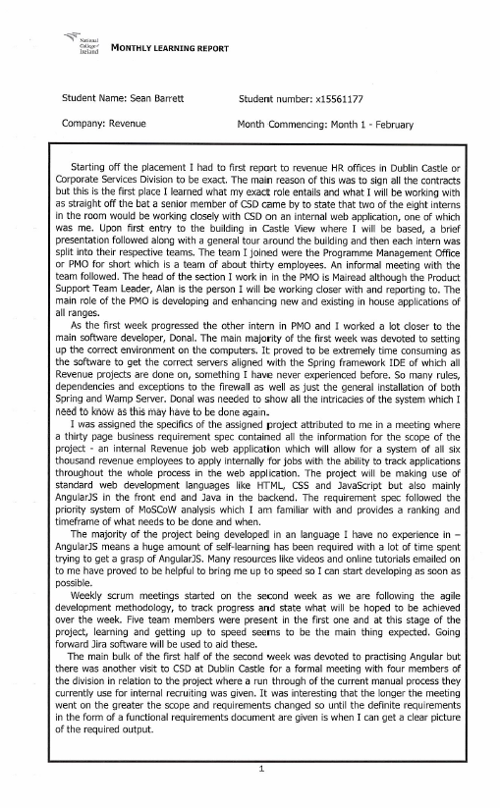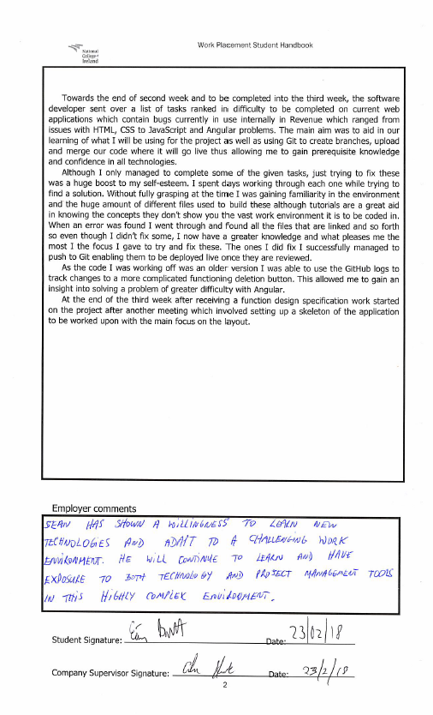

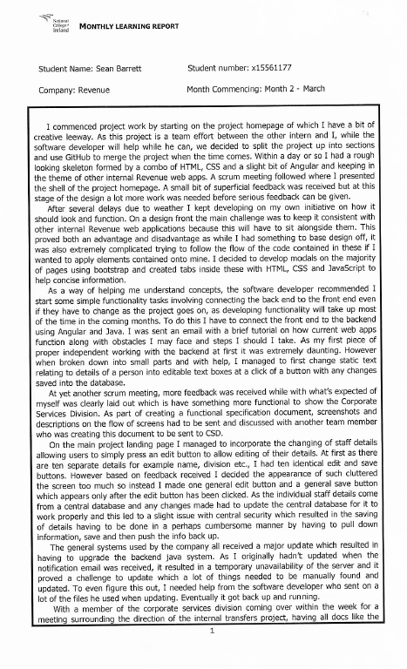

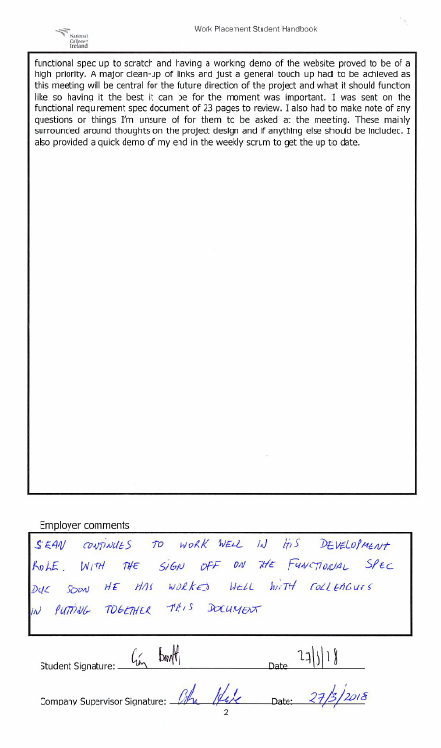

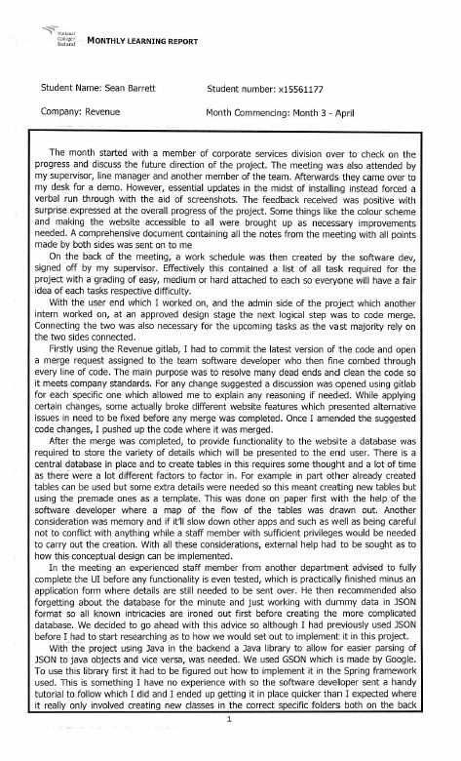

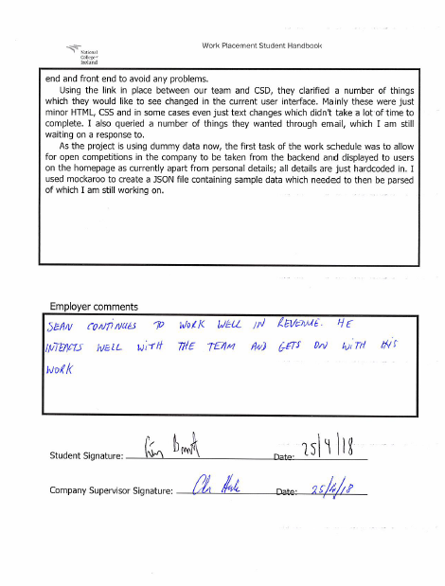

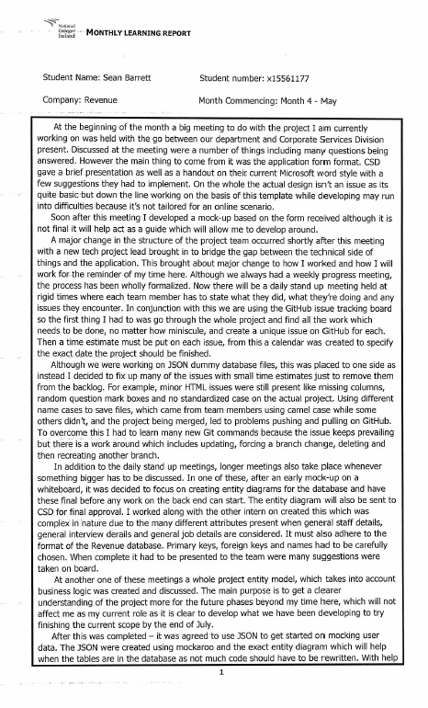

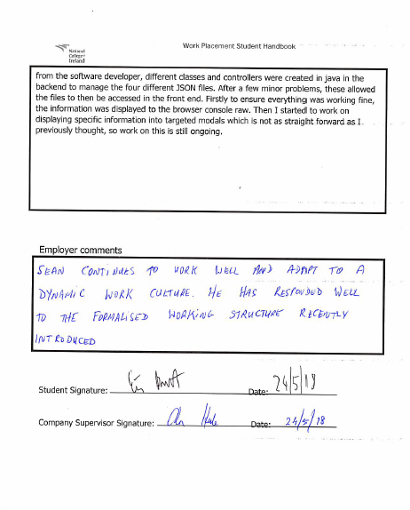

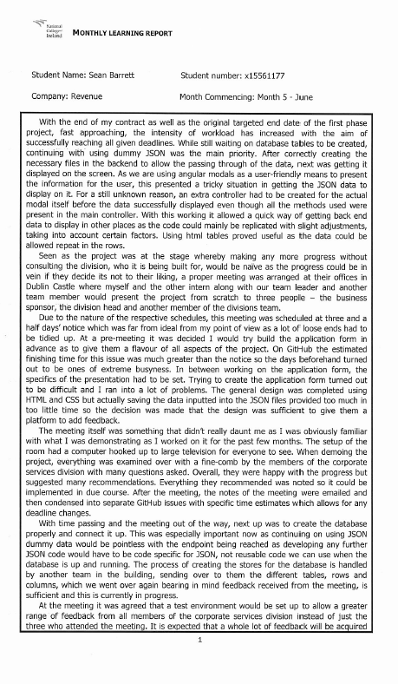

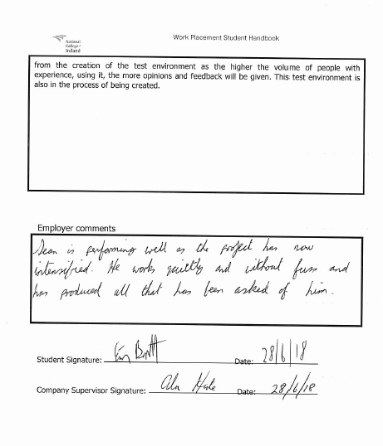

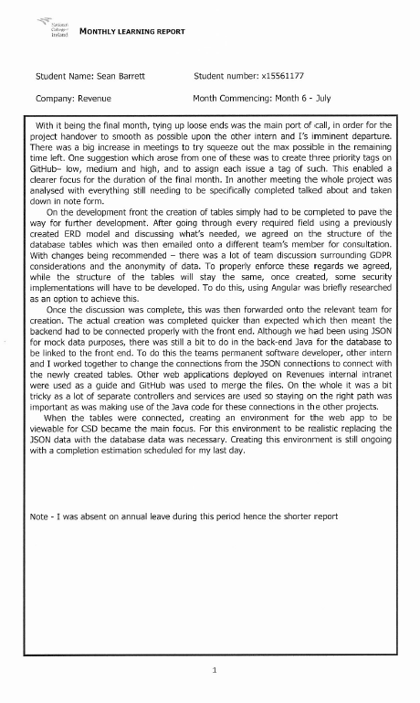

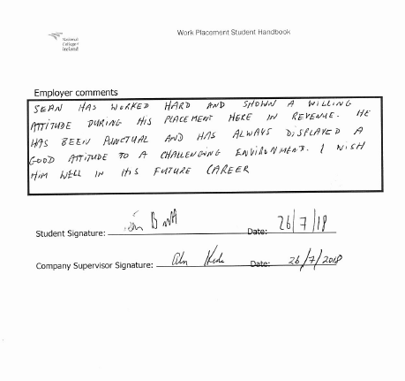

## Student self-assessment evaluation

**Student's Surname:**

**Forename(s):**

**Study Area:**

**Student I.D. No:**

**Company name :**

**Ratings explained:**

5 Excellent Always demonstrates this ability/consistently exceeds expectations

4 Good Usually demonstrates this ability/sometimes exceeds expectations

3 Fair Sometimes demonstrates this ability/ meets expectations

2 Poor Seldom demonstrates this ability/rarely meets expectations

1 Unsatisfactory Never demonstrates this ability/does not meet expectations

**JOB DESCRIPTION: Assessment of performance in aspects of job as given in Placement Agreement.**

**Please rate your performance in each area by entering a number (1-5) in each box:**

If you have not performed any of the duties listed, indicate using N/A (not applicable).

|  |  |
| --- | --- |
| **DUTY** | **Rating** |
| Develop internal job web application from scratch to cater for five thousand Revenue staff using AngularJS | 3 |
| Design and create relevant database to correctly store data for use on mentioned web application project. | 4 |
| Liaise with stakeholders to design a user interface which accommodates for all staff even those with disabilities for said project. | 3 |
| Accurately break down project into separate issues using GitLab for purposes including scheduling and the ability to merge for a more seamless development amongst the team. | 4 |
| Attend and participate in daily meetings relating to project | 2 |
|  |  |
| Other: not specified in job description but undertaken whilst on placement (please indicate): |  |

**Employability Skills:**

Looking back on your work experiences and learning from them is important in building up a greater self-awareness of the strengths and weaknesses in your skills-set. This assessment will assist you later in successfully projecting yourself at interviews. Please indicate in the form below the standard to which you feel you have developed each skill during your work placement

Please rate your employability skills by entering a number (1-5) in each box:

Employability Skills:

|  |  |  |  |  |  |  |  |  |  |  |  |  |
| --- | --- | --- | --- | --- | --- | --- | --- | --- | --- | --- | --- | --- |
| **1** | **Ability to Learn** | | | | | | | | | | | |
|  | a | Asks pertinent and purposeful questions | [5] | | [4] | | [3] | | [2] | | [1] | |
|  | b | Seeks out opportunities and utilises appropriate resources | [5] | | [4] | | [3] | | [2] | | [1] | |
|  | c | Accepts responsibility for mistakes and learns from experiences | [5] | | [4] | | [3] | | [2] | | [1] | |
|  | d | Seeks feedback on personal development from colleagues | [5] | | [4] | | [3] | | [2] | | [1] | |
|  |  | | | | | | | | | | | |
| **2** | **Reading/Writing/Communication Skills** | | | | | | | | | | | |
|  | a | Reads/Comprehends/Follows written materials | [5] | | [4] | | [3] | | [2] | | [1] | |
|  | b | Communicates ideas and concepts clearly in writing | [5] | | [4] | | [3] | | [2] | | [1] | |
|  | c | Works within procedures appropriate to the job | [5] | | [4] | | [3] | | [2] | | [1] | |
|  |  |  |  | |  | |  | |  | |  | |
| **3** | **Listening and Oral Communications Skills** | | | | | | | | | | | |
|  | a | Listens to others in an effective and attentive manner | [5] | | [4] | | [3] | | [2] | | [1] | |
|  | b | Effectively participates in meetings and/or group settings | [5] | | [4] | | [3] | | [2] | | [1] | |
|  | c | Demonstrates effective verbal communication skills | [5] | | [4] | | [3] | | [2] | | [1] | |
|  |  |  |  | |  | |  | |  | |  | |
| **4** | **Creative Thinking and Problem Solving Skills** | | | | | | | | | | | |
|  | a | Breaks down complex tasks/problems into manageable pieces | [5] | | [4] | | [3] | | [2] | | [1] | |
|  | b | Brainstorms/develops options and ideas | [5] | | [4] | | [3] | | [2] | | [1] | |
|  | c | Demonstrates an analytical capacity | [5] | | [4] | | [3] | | [2] | | [1] | |
|  |  |  |  | |  | |  | |  | |  | |
| **5** | Professional and Career Development Skills | | | | | | | | | | | |
|  | a | Exhibits a self-motivated approach to work | | [5] | | [4] | | [3] | | [2] | | [1] |
|  | b | Demonstrates ability to set appropriate priorities/goals | | [5] | | [4] | | [3] | | [2] | | [1] |
|  | c | Exhibits professional behaviour and attitude | | [5] | | [4] | | [3] | | [2] | | [1] |
|  |  |  | |  | |  | |  | |  | |  |
| **6** | **Interpersonal and Teamwork skills** | | | | | | | | | | | |
|  | a | Manages and resolves conflict in an effective manner | | [5] | | [4] | | [3] | | [2] | | [1] |
|  | b | Supports and contributes to a team atmosphere | | [5] | | [4] | | [3] | | [2] | | [1] |
|  | c | Demonstrates assertive but appropriate behaviour | | [5] | | [4] | | [3] | | [2] | | [1] |
|  |  |  | |  | |  | |  | |  | |  |
| **7** | Organisational Effectiveness Skills | | | | | | | | | | | |
|  | a | Seeks to understand and support the organisations mission/goals | | [5] | | [4] | | [3] | | [2] | | [1] |
|  | b | Fits in with the norms and expectations in the organisation | | [5] | | [4] | | [3] | | [2] | | [1] |
|  | c | Works within appropriate decision-making channels | | [5] | | [4] | | [3] | | [2] | | [1] |
|  | d | Is sensitive to organisational politics | | [5] | | [4] | | [3] | | [2] | | [1] |
|  |  | | | | | | | | | | | |
| **8** | **Basic Work Habits** | | | | | | | | | | | |
|  | a | Reports to work as scheduled and on time | | [5] | | [4] | | [3] | | [2] | | [1] |
|  | b | Exhibits a positive and constructive attitude | | [5] | | [4] | | [3] | | [2] | | [1] |
|  | c | Dress and appearance are appropriate for this organisation | | [5] | | [4] | | [3] | | [2] | | [1] |
|  | d | Is clear about what the organisation expects | | [5] | | [4] | | [3] | | [2] | | [1] |
|  |  | | | | | | | | | | | |
| **9** | **Cultural Adaptation (International placements only)** | | | | | | | | | | | |
|  | a | Is conscious of different cultural values | | [5] | | [4] | | [3] | | [2] | | [1] |
|  | b | Is sensitive to others with different cultural backgrounds | | [5] | | [4] | | [3] | | [2] | | [1] |
|  | c | Uses the working environment to extend his level of cultural awareness | | [5] | | [4] | | [3] | | [2] | | [1] |

**ACADEMIC REQUIREMENTS:**

**Please indicate your status with respect to each of the following elements:**

|  |  |  |  |  |  |
| --- | --- | --- | --- | --- | --- |
|  |  |  |  |  |  |
| Completion of work-based learning elements | [5] | [4] | [3] | [2] | [1] |

**GENERAL FEEDBACK/COMMENTS:**

|  |  |  |  |  |  |
| --- | --- | --- | --- | --- | --- |
| Is the work challenging? | [5] | [4] | [3] | [2] | [1] |
| Is there appropriate support/supervision? | [5] | [4] | [3] | [2] | [1] |
| Are there well defined work targets to be achieved/projects to be completed | [5] | [4] | [3] | [2] | [1] |
| Career Goals – is the placement helping to clarify career objectives | [5] | [4] | [3] | [2] | [1] |

* Would you consider that this has been a successful placement, both from a Company and Student point of view? – Explain in terms of how you have both benefited from the placement

I would definitely state has been a successful for both parties. On my side, I gained great___ experience I feel I wouldn’t have received elsewhere working on a proper project, treated the whole time like full time employee. On the company side, having being part of a small______ development team I was a key part in the progression of the project I worked on from the__ very start to the point we got to. ________________________________________________

* How do you feel this placement will benefit you in the future?

The placement will greatly benefit me in the future because I was really involved a professional team environment and project from the start of my time right to the end. I now know the process and the inner dynamics of how these things work so going forward not only will this look great on my CV, it will also be great for when I start any future job opportunity as I know I won’t feel overawed.

* Do you have any suggestions for other student placements of this kind in the future?

Pre- to accepting any offer, any student should know exactly their role and what team they’ll be placed in because this year, Revenue took on ten interns with them placed in 7 different teams across the Castle View building. Each team is vastly different so they should know what languages they’ll be developing to prevent a shock on the first day. They should try network with the any team leaders who are also contractors as they may be able to advise them on future prospects as there aren’t many IT prospects for internal Revenue staff.

**Student’s Signature: Date:**

**Title/Position:**

**Telephone:**